Standard Operating Procedure

1. Purpose
This Standard Operating Procedure (SOP) provides clear, repeatable guidance for the duties of the MEMS Academy State Director (ASD). It ensures uniform administration of MEMS training packets, application processing, recordkeeping, and coordination with the State Guard Association of the United States (SGAUS) and MEMS Academy Headquarters.

2. References

https://sgaus.org/mems-academy/

Frequently check website before performing the procedure to evaluate changes in program, requirements, or curriculum changes.

3. Scope
This SOP applies to the MEMS ASD — newly appointed or currently serving—who manage the submission, review, tracking, and approval of MEMS certification packets for Basic, Senior, and Master, as well as the All Hazards LNO, Professional and Executive Emergency Manager certifications.

4. Responsibilities

State Director (ASD)

The ASD is responsible for:

- Receiving, logging, and tracking all MEMS packets.
- Ensuring compliance with the latest SGAUS MEMS policies.
- Reviewing practicum submissions for completeness and accuracy.
- Verifying training requirements.
- Certifying packets and routing them to Academy HQ when appropriate.
- Maintaining secure and organized records.
- Supporting applicants with clear instructions and guidance.
- Performing quality assurance on state-level MEMS activity.

Deputy ASD (if assigned)

Supports the ASD by:

- Performing packet pre-checks.
- Managing administrative documentation.
- Updating logs under ASD guidance.

5. Procedure

Step 1: Receive packet from applicant.

Step 2: Log into the MEMS Packet Tracking Sheet.

Step 3: Verify prerequisites, ensure SGAUS Membership for each level and completion of all tasks.

Step 4: Review practicum, application, and checklist forms.

Step 5: Check the SGAUS website for updated policies or forms.

Step 6: Determine eligibility date for next-level submission.

Step 7: Approve or request corrections from the applicant.

Step 8: Complete Certificate of Award, Memorandum for Record, and compile documentation into single document,

Step 9: Send award notification email to applicant, their chain of command (if known), and attach PDF of the Certificate of Award, Memorandum For Record, and completed packet for Student’s records.

Step 10: File and retain records per this SOP.

6. MEMS Packet Tracking Requirements
ASDs will maintain a Master MEMS Packet Tracking Log. This may be Excel, Google Sheets, or another editable format.

Recommended Format:

Fields in Tracking Log:

FIELD | DESCRIPTION
Receipt Date | Date of packet Receipt
ORG | Organization or Agency
Last | Last Name
First | First Name
Rank | Rank (if applicable)
Phone | Contact phone number
Email | Contact email
FEMA Student ID | FEMA Student ID Number
Unit / AGENCY | Unit within organization or agency
BMEMB | Basic MEMS Badge Award Date
SMEMB | Senior MEMS Badge Award Date
NET | Master Application No Earlier Than date
MMEMB | Master MEMS Badge Award Date
AHLNO | All Hazards LNO Award Date
EEM | Executive Emergency Manager Award Date
PEM | Professional Emergency Manager Award Date
Notes | Current SGAUS membership date

7. Required Forms and Document References

7.1. Fillable Application & Practicum Template

ASD must provide students with the fillable MEMS Application & Practicum template.
Ensure applicants use the latest version by downloading from a SharePoint locations or supplying by email. fresh copies for each class or packet cycle. This template is managed by ASD and is to be updated with every revision in the core program at SGAUS to ensure compliance with program requirements.

7.2 Additional Helpful Documents

ASD provides a checklist for each submission to ensure applicants have completed all prerequisites prior to practicum application. Checklists include:

- BASIC MEMS Checklist
- SENIOR MEMS Checklist
- Master MEMS Checklist

8. Validation of Current SGAUS Materials

Before processing any new packet:

- Visit the SGAUS website.

- Navigate to: Programs → MEMS Academy.

- Confirm:

- Latest Certification Application

- Latest Practicum Template

- Latest Academy Handbook / Policy Updates

- Any recent MEMS Academy announcements

- Only accept packets using current forms unless grandfathering is authorized.

ASD Note: Printing or saving outdated documents leads to certification delays. Mandatory verification is required for each packet processed.

9. Packet Processing Procedures

This section covers the basics of processing the packet.

9.1 Receiving a Packet

- Acknowledge receipt by email.

- Assign the packet a unique tracking number.

- Log into the Master Tracking Sheet.

9.2 Packet Review Standards

Check for:

- Completed ICS requirements

- Completed Checklist

- Completed practicum (Basic/Senior/Master)

- Correct version of application

- Supporting objective evidence

- Evidence of AI tool use (fabricated practicums)

- Completion of all ICS Courses on exact same date (i.e. doing a week’s worth of classes in one day)

9.3 Corrections Request Procedure

If incomplete:

- Send a clear, written request identifying required corrections.

- Pause processing until full materials are returned.

- Keep correspondence in the packet’s electronic folder (email file folder).

9.4 Approval Procedure

Once the packet meets all criteria:

- Update the Tracking Sheet with the award date.

- Sign the Certificate of Award.

- For Senior-level packets, identify the NET date for Master application requirement

- Create a Memorandum for Record (MFR). An example of MFR found in Appendix A.

- Compile all certificates or FEMA Transcript and checklist into final document and convert to PDF.

- Issue certificate, MFR, and final completed packet to Applicant and their chain of command (if known) via email. An example of an award email template is in Appendix B.

- Reference Appendix C for packet completion checklist.

10. Determining eligibility for Master Submission

- Minimum timeline: 6 months from Senior award date, unless superseded by updated policy.

- ASD will track “Not Earlier Than (NET)” dates in the Master Log.

- Applicants should NOT submit early packets unless grandfathering has been announced, or at discretion of ASD with guidance from SGAUS MEMS Academy Commandant (rare cases).

11. Communication Standards
ASDs shall:

- Respond to applicant emails within 5 business days.

- Provide clear, constructive feedback.

- Maintain a courteous mentoring approach consistent with the ethos of MEMS Academy.

- Complete within 2 weeks of receipt. If unable, provide estimated timing expectation to applicant for transparency.

12. Filing System & Record Retention

ASD must maintain a structured filing system—electronic or hybrid—to preserve objective evidence.

12.1 Recommended Folder Structure

/MEMS State Director Files
/Year
/Applicant (Lastname, Firstname)
/ BASIC
Document1: Final processed Application & Practicum.pdf
Document2: Memorandum_For_Record.pdf
Document3: Certificate_of_Award.pdf
/ SENIOR
Document1: Final processed Application & Practicum.pdf
Document2: Memorandum_For_Record.pdf
Document3: Certificate_of_Award.pdf
/ MASTER
Document1: Final processed Application & Practicum.pdf
Document2: Memorandum_For_Record.pdf
Document3: Certificate_of_Award.pdf

12.2 Retention Requirements

- Minimum: Retention for all packet materials and correspondence for the time as ASD.
- Secure all files to protect PII.
  - Maintain a digital backup (cloud or external drive) to be forwarded to your replacement ASD.
12.3 Objective Evidence Includes

- ICS certificates
- Completed practicum activities and SGAUS membership

- Meeting logs
- Deployment logs (if used toward practicum)
- Copies of signed applications
- ASD feedback notes

13. Quality Assurance
ASD should conduct:

- Quarterly reviews of packet files for completeness.
- Annual self-audit, ensuring:
- Tracking sheet is up to date
- Forms used are current
- No packets are overdue
- Records are properly archived

14. New ASD Transition Checklist
When transitioning to a new ASD:

- Transfer the full Master Tracking Log.

- Provide the last 5 years of packet files.

- Provide updated links to all current forms.

- Provide a summary of pending packets and required actions.

- Ensure the outgoing ASD briefs the incoming ASD.

Appendix A: Award MFR Example

BASIC MEMS Example: A letter can be created by each ASD.

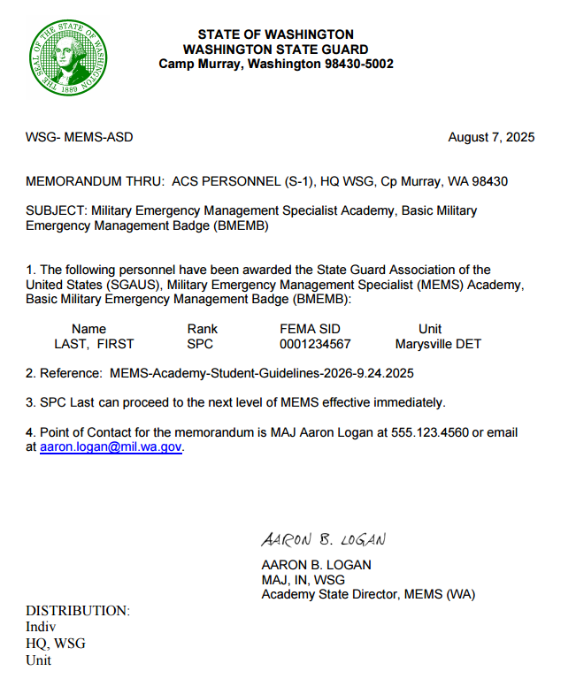

Appendix A: Award MFR Example (continued)

SENIOR MEMS:

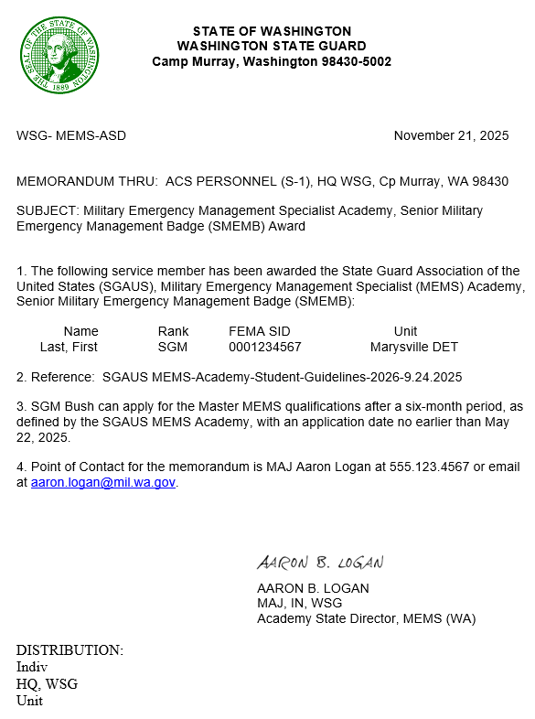

Appendix A: Award MFR Example (continued)

MASTER MEMS:

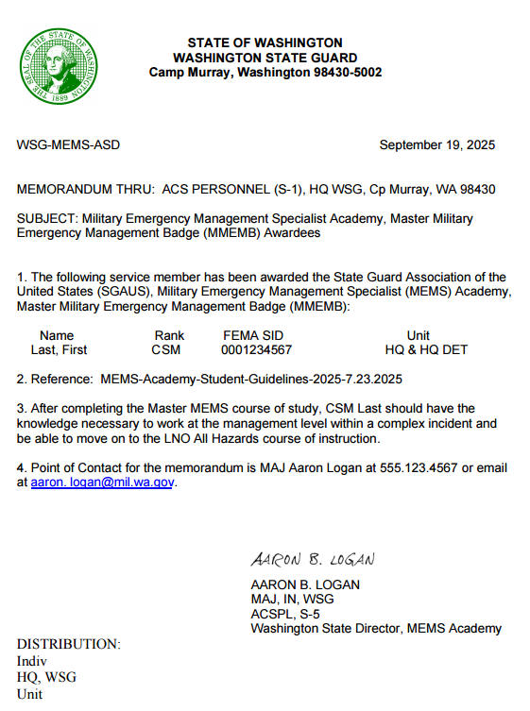

Appendix B: ASD Email Template

Rank Lastname,

Congratulations on Earning the Basic Military Emergency Management Specialist Badge!

It is with great pleasure that I extend my sincerest congratulations for achieving the Basic Military Emergency Management Specialist (MEMS) Badge.

Issued through the State Guard Association of the United States (SGAUS), this badge symbolizes your dedication, skill, and proficiency in the field of emergency management.

You are hereby authorized to purchase and proudly wear* the Basic MEMS badge, reflecting your commitment to excellence in emergency preparedness and response.

An electronic certificate of award is attached along with the memorandum document and your completed practicum for your personal records. The physical award certificate will be presented to you either at the next drill (if possible) or sent to your email. If you have the physical qualification badge, you may wear it effective immediately.

Furthermore, it is important to note that you may now embark on a new journey toward the Senior MEMS Badge. Once prepared, you may submit a practicum and certificates and apply for the esteemed Senior MEMS Badge.

Once again, congratulations on this remarkable achievement. Your dedication and expertise serve as an inspiration to us all.

* Authorization for wear is granted in the Washington State Guard; National Guard and other agencies should check with your command for authorization to wear this qualification badge.

Best regards,

Academy State Director
State Guard
Address
ASD Email:
Phone:

Appendix C: Quick Reference Checklist for Packet Review

☐ Verified latest SGAUS MEMS requirements
☐ Application is complete
☐ Practicum complete and signed
☐ ICS / prerequisite requirements included
☐ Award dates calculated
☐ Packet logged
☐ Objective evidence stored
☐ Applicant notified

